**PROJECT REPORT**

**-------------------------------------------------------**

Name :ANAPARTHI PRATYUSHA

Email : [anaparthipratyusha@gmail.com](mailto:anaparthipratyusha@gmail.com)

Phone no : +918639891204

------------------------------------------------------------------------------

**COMPANY MEMBER TEAM WEB PAGE**

Your first project task is to develop a responsive web page for the Company Member Team Page. The design reference is provided in the attached file named "designed-1." Utilize HTML and CSS to bring this design to life, ensuring responsiveness across various devices. This project allows you to showcase your coding skills and creativity while adhering to the design reference.

--------------------------------------------------------------------------------------------------

I create a folder and I opened it in visual studio code and I create a new files in that folder.

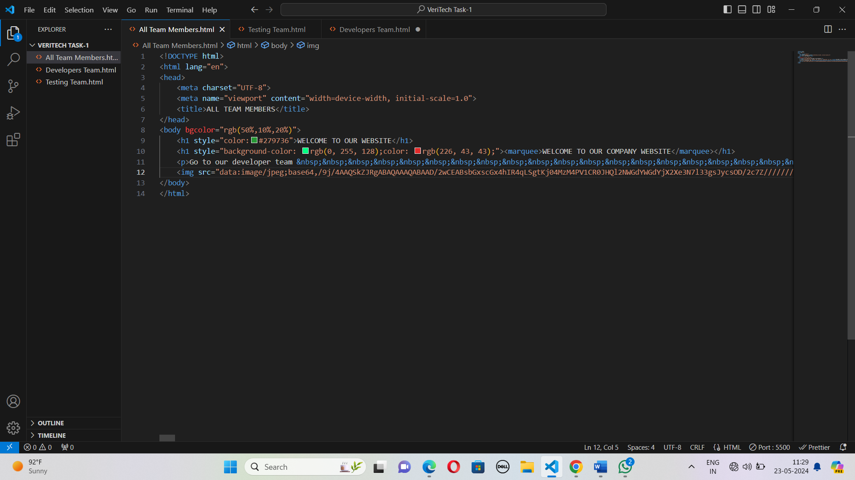

I create a main file that is main web page. In this webpages I used html and css.

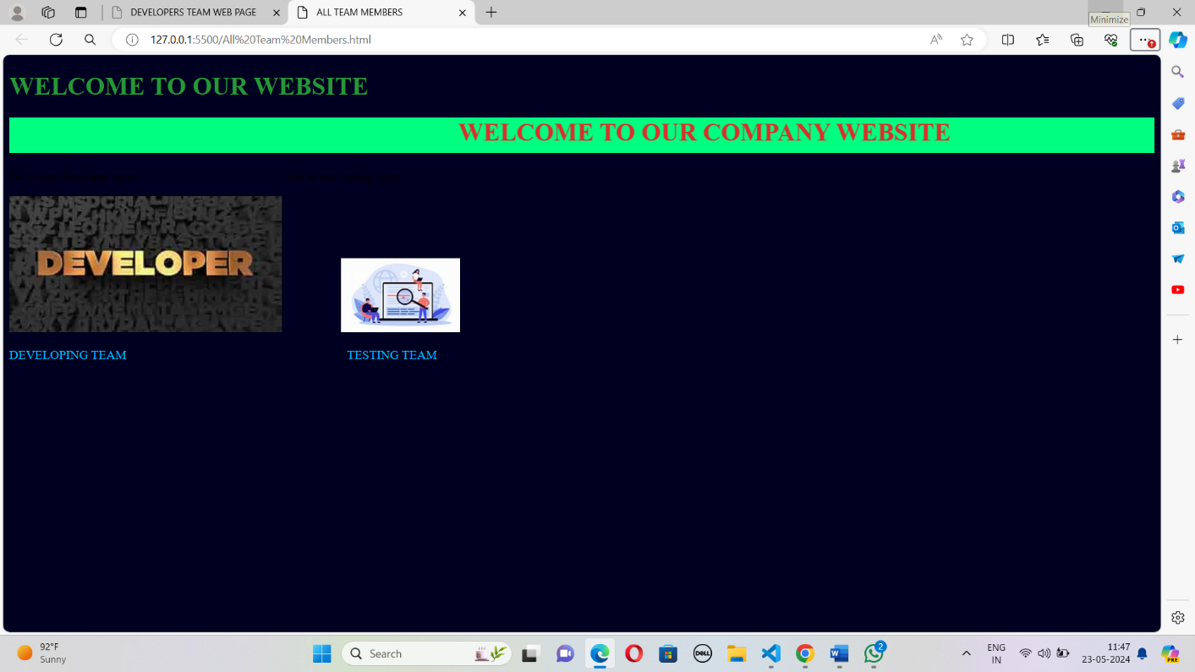

In this web page I used marquee tag for attraction. If you click on the developer image it will open the developer team web page, and click on the testing image it will open testing team web page.

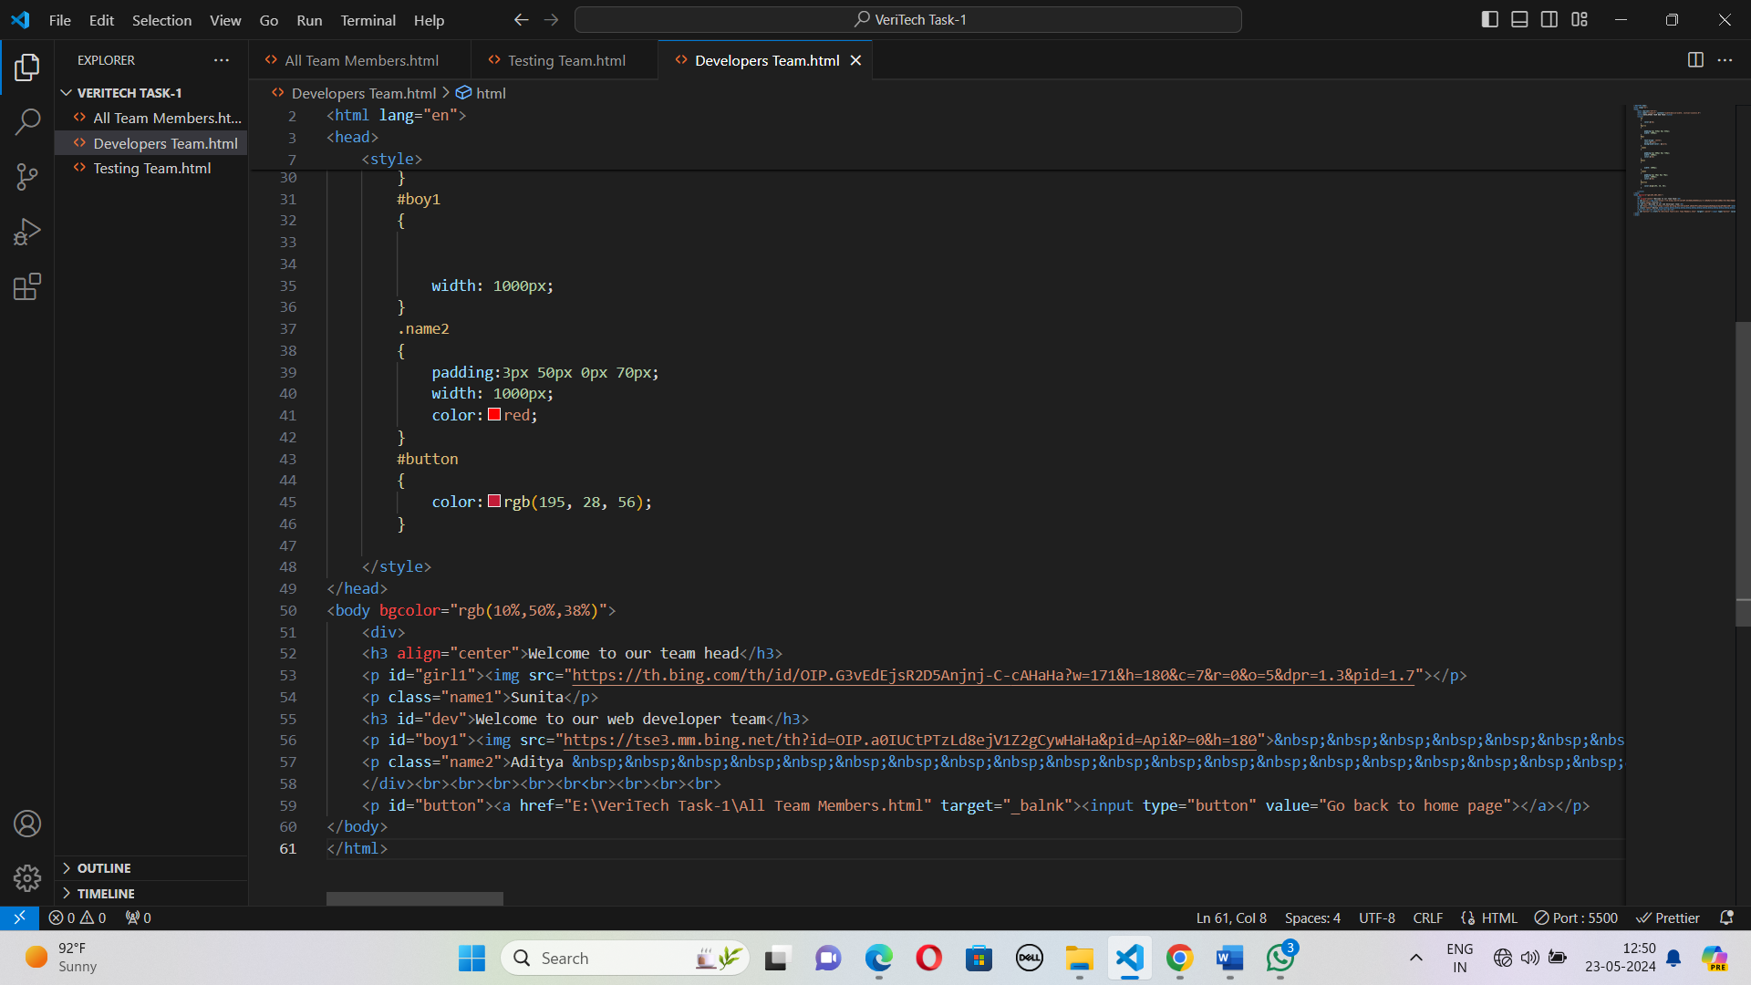

This is the output of the developers team web page.

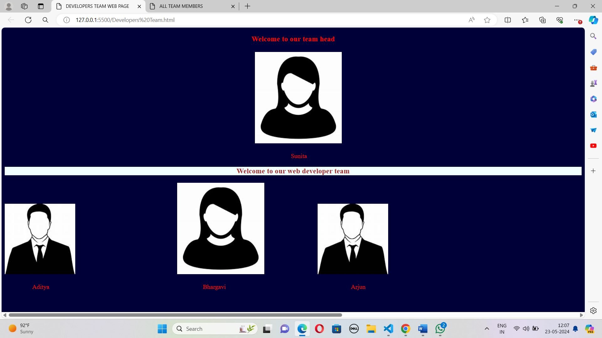

This is the code of the testing team web page code.

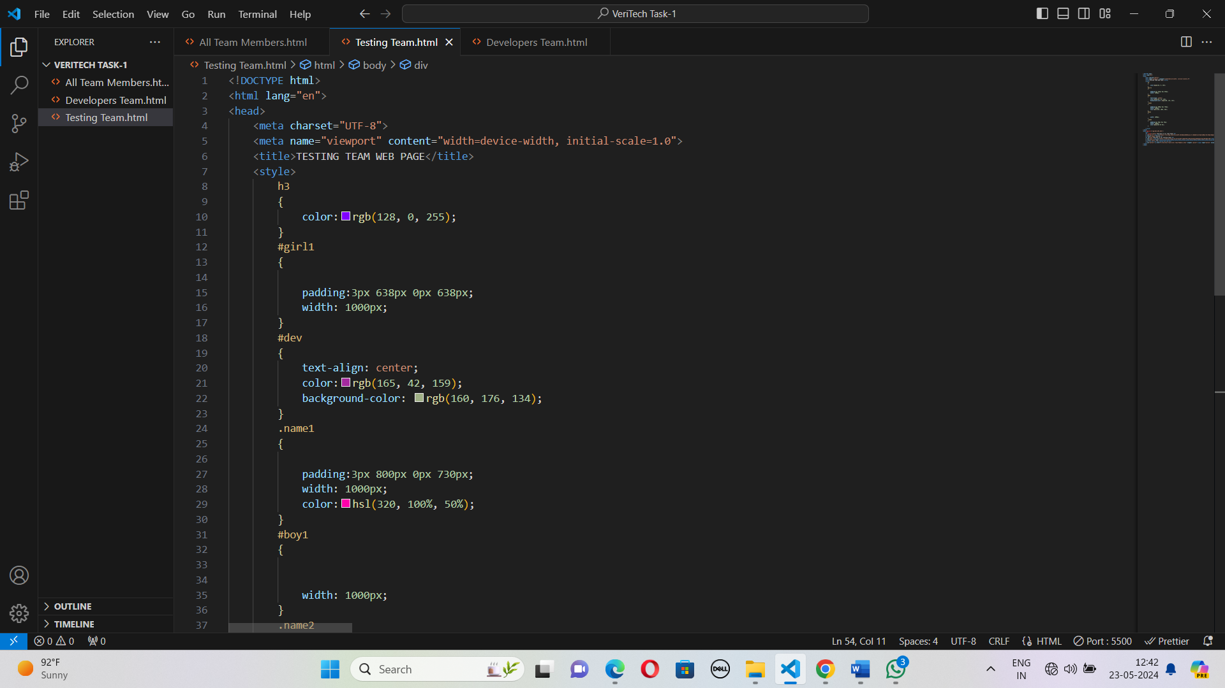

This is the output of the testing team web page.

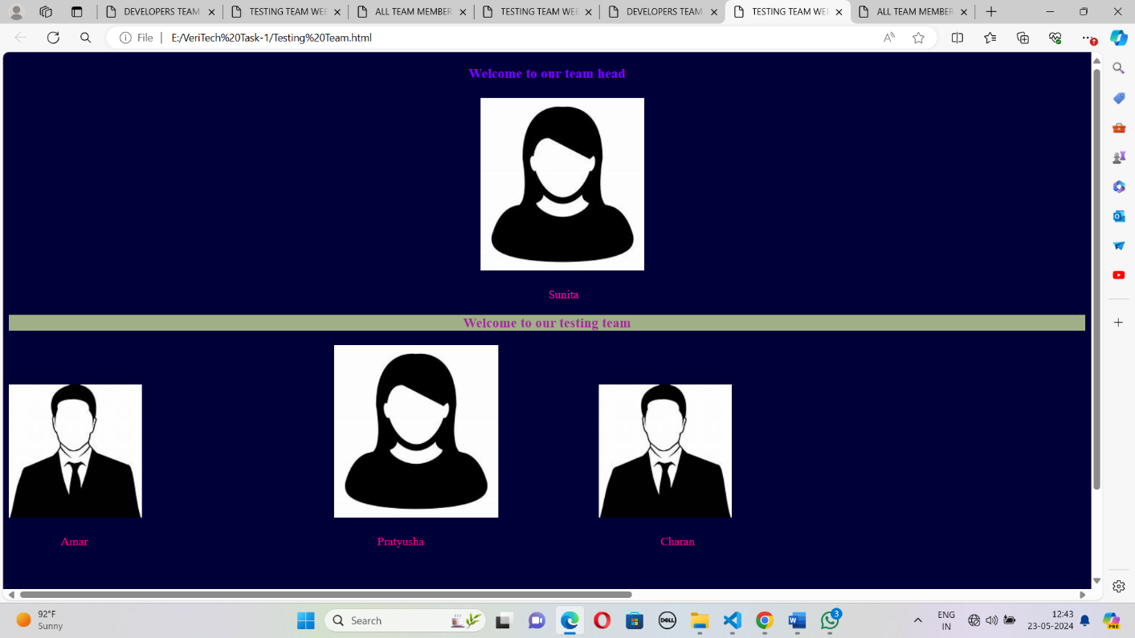

In this I create a button to go back to home page.

